**CSV to XML Maturity Calculator Basic Documentation**

Framework: **Laravel**

Plugins

* Laravel Excel v2.1.* for Laravel 5
* Spatie Array-to-XML

Other tools: **Bootstrap**

**Structure:**

1. Basic view with file uploader input

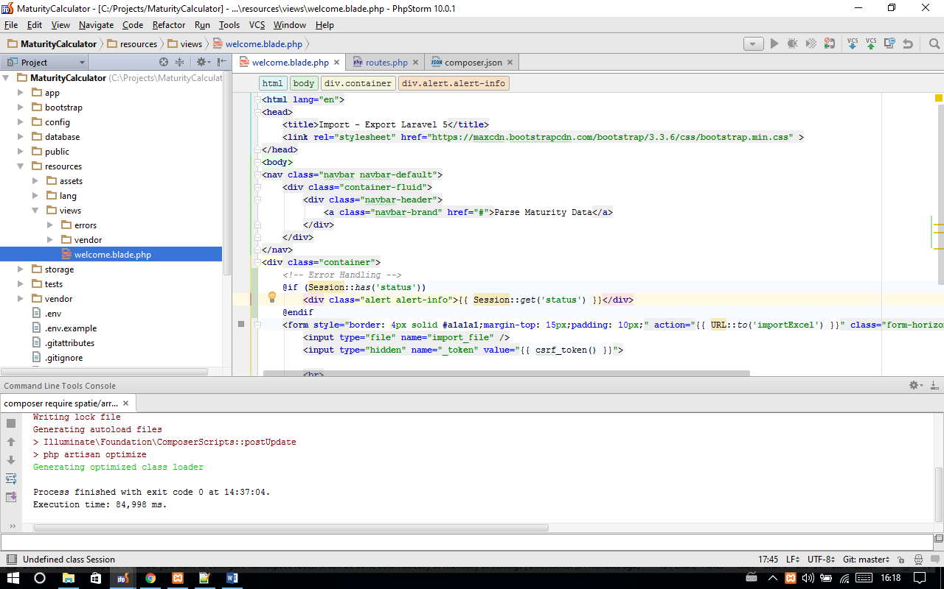

1. Routes to Homepage and to CSV Importer

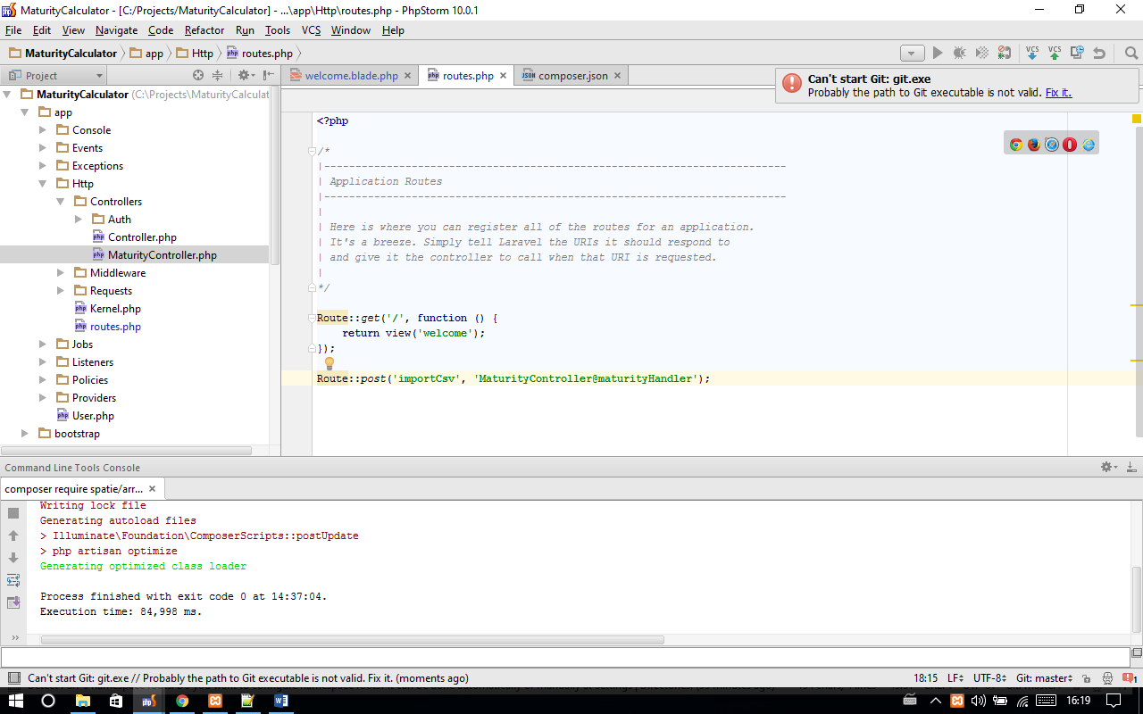

1. Controller with 5 functions to parse and output xml file. 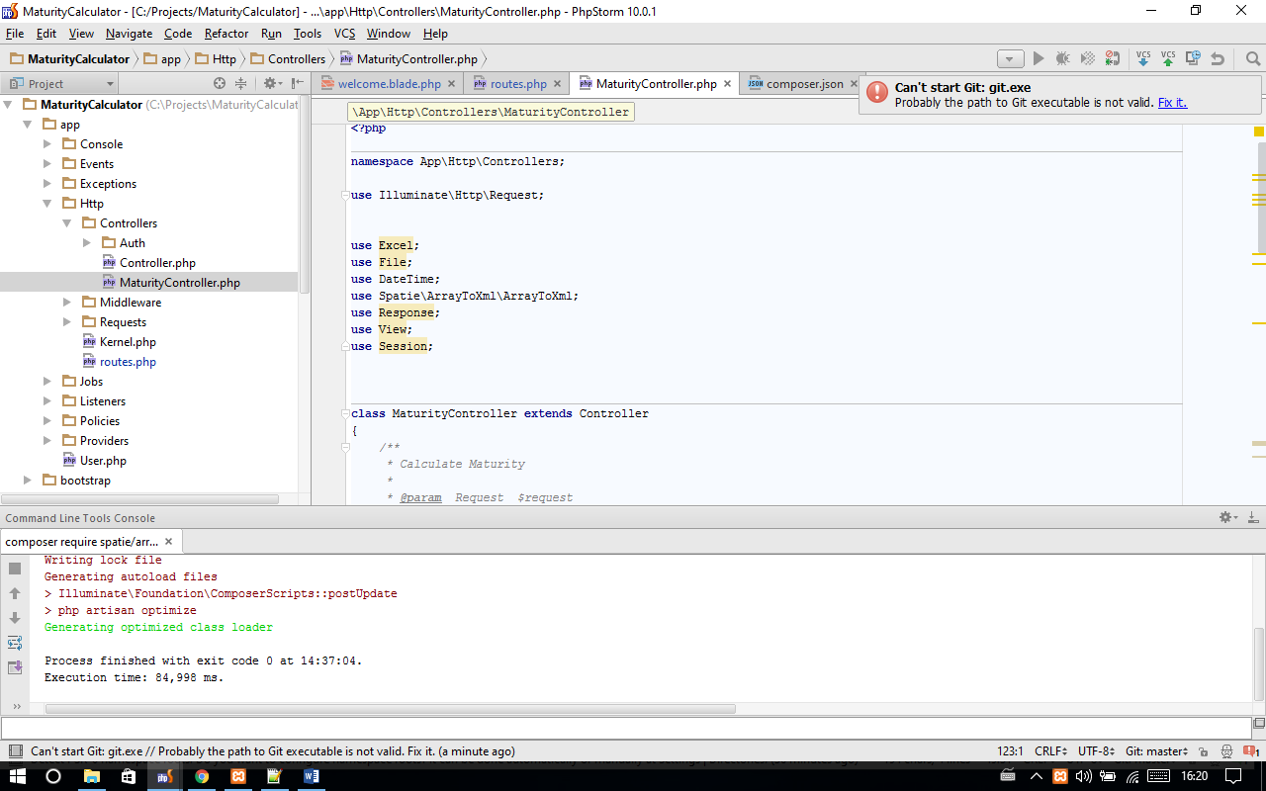
2. File are downloaded after upload and parsing and stored under storage with time of upload.

